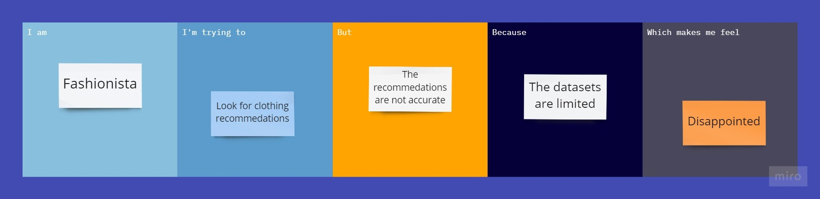

**SOLUTION FIT**

|  |  |  |
| --- | --- | --- |
| **1. CUSTOMER SEGMENT**  He/she is devoted follower of the latest fashion trends. | **2.JOBS-TO-BE-DONE**  The recommendations that are generated are not accurate enough. | **3.TRIGGERS**  Seeing their peers use an application that provides a more accurate and favored output. |

|  |  |  |
| --- | --- | --- |
| **4.EMOTIONS:BEFORE/AFTER**  BEFORE-Disappointed and dissatisfied.  AFTER-Happy and satisfied. | **5.AVAILABLE SOLUTIONS**  Going to an in-person store to look for more options instead of an online application | **6.CUSTOMER CONSTRAINTS**  Lack of resources, low budget, transportation issue and lack of stores. |

|  |  |  |
| --- | --- | --- |
| **7.BEHAVIOUR**  DIRECTLY RELATED-Find an application that has a wider range of options or check for update in the current application to get better recommendations.  INDIRECTLY ASSOCIATED-Customer visits fashion runways and exhibits frequently. | **8.CHANNELS OF BEHAVIOUR**  ONLINE-Do research on what application works the best for their individual need for better satisfaction.  OFFLINE-Goes to fashion related events to get a better understanding on fashion so that they don't need to reply on the application much. | **9.PROBLEM ROOT CAUSE**  Customers have to keep updating with the ever growing technology where things get old or outdated easily. |

|  |
| --- |
| **10.YOUR SOLUTION**  Create an application with a primary goal to provide a better recommendations ie. provide many more datasets as training and testing set to get a more accurate result. |